User behavior Analysis For Data Driven Decision Making

**Ramani.P1, Sahaana k2, Srinath R3, Swetha S4,Vasantha Krishnan R5**

*2,3,4,5 Student, Department of Artificial Intelligence and Data Science, KGISL Institute of Technology, Coimbatore, India*

*Assitant Professor,Department of Artificial Intelligence and Data Science , KGISL Institute of Technology,Coimbatore,India*

***Abstract*: Tracking real-time user behavior is essential for businesses to gain actionable insights and optimize customer experiences. This project develops a scalable web application that efficiently processes and analyzes high-frequency user interactions using Apache Kafka for real-time data streaming and Cassandra for scalable storage. MySQL is used for temporary structured data storage before migration to Cassandra. To further enhance processing capabilities, PySpark is integrated for distributed data processing and advanced analytics on large-scale datasets, ensuring fast and efficient computations. Additionally, Redis is implemented as an in-memory data store for real-time caching, session management, and quick access to frequently used data, improving overall system performance.**

**The system captures user activities, such as product clicks and browsing patterns, to generate valuable analytics. Power BI provides interactive dashboards for real-time data visualization, enabling businesses to refine marketing strategies, enhance engagement, and personalize customer experiences. By leveraging this robust architecture, the solution overcomes challenges related to massive data volumes, performance bottlenecks, and delayed insights. It also ensures data security and compliance, making it a reliable tool for data-driven decision-making. With real-time tracking, predictive analysis, and scalable components, businesses can stay competitive by identifying trends, improving strategies, and optimizing customer engagement.**

**Keywords: Real-time tracking, Apache Kafka, Cassandra, Redis, PySpark, Data streaming, Power BI, User analytics, Predictive analysis.**

I.INTRODUCTION

In today’s data-driven world, understanding user behavior in real time is critical for businesses to stay competitive and deliver personalized customer experiences. However, traditional systems often fail to handle the massive volume and high velocity of user interactions—such as product clicks, page views, and navigation patterns—leading to delays in insights and inefficiencies in decision-making. To address these challenges, this paper proposes a scalable and efficient real-time user behavior tracking system that leverages modern technologies to enable seamless data collection, processing, and analysis.

The system utilizes **Apache Kafka**, a distributed streaming platform, to capture and stream user interaction data in real time, ensuring minimal latency. For scalable and high-performance storage, **Cassandra**, a distributed NoSQL database, is employed to efficiently handle large volumes of data. Smaller datasets are temporarily stored in **MySQL**, a lightweight relational database, for initial processing before being migrated to Cassandra. To further enhance responsiveness and support low-latency access to frequently queried data, **Redis** is integrated as an in-memory caching layer, improving session management and real-time analytics.

For large-scale data processing, **PySpark** is implemented, enabling distributed computation on streaming and batch data. PySpark facilitates trend detection, behavioral clustering, and predictive analysis, significantly improving processing speed and scalability across vast datasets.

The system processes the collected data to identify trends and patterns in user behavior, generating actionable insights that help businesses optimize strategies, improve engagement, and deliver personalized experiences. To enhance data visualization, **Power BI** is integrated, providing interactive dashboards that display key metrics such as user engagement, product popularity, and session duration in real time.

Data security and compliance are prioritized, with encryption and access controls implemented to protect user information and ensure adherence to privacy regulations. The system is designed for scalability and performance, capable of handling high traffic loads without bottlenecks, and incorporates efficient indexing and query optimization for faster data retrieval. This paper presents the architecture, implementation, and benefits of the proposed system, demonstrating its potential to transform real-time user behavior tracking and empower businesses with data-driven decision-making capabilities.

II. RELATED WORK

Real-time user behaviour tracking has become a cornerstone of modern business strategies, enabling organizations to gain actionable insights and deliver personalized customer experiences. However, the challenges associated with processing and analysing high-frequency interaction data have been extensively documented in existing literature. Traditional relational databases, while effective for structured data, often struggle with scalability and performance when handling large volumes of real-time data streams. Smith et al. (2020) highlight the limitations of relational databases in real-time applications, emphasizing their inability to scale horizontally and handle high-velocity data efficiently. This has led to the exploration of distributed systems and NoSQL databases, which offer better scalability and fault tolerance for real-time applications. Johnson and Lee (2019) discuss the advantages of NoSQL databases, particularly their ability to handle unstructured and semi-structured data, making them well-suited for user behaviour tracking systems.

Apache Kafka, a distributed streaming platform, has gained significant attention for its ability to handle high-throughput, low-latency data streams. Gupta et al. (2021) provide a comprehensive analysis of Kafka's architecture, highlighting its effectiveness in real-time data ingestion and processing. Kafka's publish-subscribe model decouples data producers and consumers, enabling seamless data streaming and ensuring minimal latency. This makes Kafka an ideal choice for applications requiring immediate insights, such as real-time user behaviour tracking. Furthermore, Kafka's distributed nature ensures that the system can scale horizontally to accommodate increasing data loads, addressing one of the primary challenges of real-time data processing.

For scalable and high-performance storage, Cassandra, a distributed NoSQL database, has been widely adopted in real-time applications. Patel and Kumar (2020) discuss Cassandra's decentralized architecture, which is based on the Distributed Hash Table (DHT) model. This architecture ensures that data is evenly distributed across nodes, reducing the risk of bottlenecks and single points of failure. Cassandra's ability to handle high write throughput and low latency makes it particularly well-suited for real-time user behaviour tracking systems. The CAP Theorem, which outlines the trade-offs between consistency, availability, and partition tolerance in distributed systems, provides a theoretical foundation for understanding Cassandra's design choices. Brewer (2012) explains that Cassandra prioritizes availability and partition tolerance, making it an ideal choice for systems where real-time data access and fault tolerance are critical.

While NoSQL databases like Cassandra excel at handling large-scale data, they may not be the most efficient solution for smaller datasets or temporary storage. This has led to the adoption of hybrid storage models, where lightweight databases like MYSQL are used for initial data processing before migrating data to more robust systems. Zhang et al. (2022) explore the benefits of hybrid storage systems, emphasizing MySQL simplicity, portability, and low resource requirements. MySQL ability to handle smaller datasets efficiently makes it an ideal choice for temporary storage and preprocessing tasks, reducing the load on primary storage systems like Cassandra. This hybrid approach ensures flexibility and scalability, enabling the system to adapt to varying data volumes and processing requirements.

Data visualization and analytics play a crucial role in transforming raw data into actionable insights. Power BI, a business analytics tool, has been extensively used for its interactive dashboards and real-time reporting capabilities. Brown et al. (2021) discuss the integration of Power BI with streaming platforms and databases, highlighting its ability to monitor key metrics such as user engagement, product popularity, and session duration. Power BI's visual analytics capabilities enable businesses to uncover patterns and trends in user behaviour, facilitating data-driven decision-making. The concept of Visual Analytics, as proposed by Thomas and Cook (2005), emphasizes the importance of combining automated analysis with human intuition to gain deeper insights into data. By integrating Power BI into the proposed system, businesses can leverage visual analytics to optimize their strategies and enhance customer experiences .Security and compliance remain critical concerns in real-time data systems. Anderson et al. (2020) emphasize the importance of encryption, access controls, and adherence to privacy regulations such as GDPR and CCPA in protecting user data. The Confidentiality, Integrity, and Availability (CIA) triad provides a theoretical foundation for understanding the key principles of data security. By implementing encryption for data transmission and storage, and enforcing strict access controls, the proposed system ensures that user data is protected from unauthorized access and breaches. Compliance with privacy regulations is essential for maintaining user trust and ensuring the ethical use of behavioural data.

Scalability and performance optimization are recurring themes in the literature. Techniques such as efficient indexing, query optimization, and load balancing have been proposed to address performance bottlenecks in high-traffic systems. Wang et al. (2021) discuss the importance of these techniques in ensuring that real-time systems can handle increasing data volumes without compromising latency or reliability. The proposed system incorporates these techniques to ensure optimal performance, even under high traffic loads. Additionally, the Lambda Architecture and Kappa Architecture provide theoretical frameworks for designing real-time data processing systems. Marz and Warren (2015) explain that the Lambda Architecture combines batch and stream processing layers to provide both real-time and historical insights, while the Kappa Architecture simplifies this model by treating all data as streams. The proposed system aligns more closely with the Kappa Architecture, leveraging Kafka for real-time streaming and processing, ensuring that all data is handled in a unified manner.

In summary, existing research underscores the importance of distributed systems, NoSQL databases, hybrid storage models, and advanced analytics tools in addressing the challenges of real-time user behaviour tracking. However, there is a need for integrated solutions that combine these technologies into a cohesive system capable of delivering real-time insights while ensuring scalability, security, and compliance. This paper builds on these foundations to propose a comprehensive solution for real-time user behaviour tracking, leveraging Apache Kafka, Cassandra, MySQL, and Power BI to address the limitations of traditional systems and empower businesses with actionable insights.

III. PROPOSED APPROACH

The proposed solution is a scalable and efficient real-time user behavior tracking system designed to address the challenges of processing and analyzing high-frequency user interactions. The system integrates modern technologies such as **Apache Kafka**, **Cassandra**, **MySQL**, **Redis**, **PySpark**, and **Power BI** to enable seamless data collection, storage, processing, and visualization. The architecture of the solution is designed to handle large volumes of data while ensuring minimal latency, scalability, and security.

The system leverages **Apache Kafka** for real-time data ingestion and streaming. Kafka's distributed architecture ensures high throughput and low latency, making it ideal for capturing user interactions such as product clicks, page views, and navigation patterns. Data producers, such as web and mobile applications, send user interaction events to Kafka topics, which are then consumed by downstream components for processing and storage. Kafka's publish-subscribe model decouples data producers and consumers, enabling scalability and fault tolerance. This ensures that the system can handle high-frequency data streams without performance bottlenecks.

For efficient storage of large volumes of user interaction data, the system employs **Cassandra**, a distributed NoSQL database. Cassandra's decentralized architecture ensures high availability and fault tolerance, making it well-suited for handling high write throughput and low-latency queries. The system also uses **MySQL**, a lightweight relational database, for temporary storage of smaller datasets. MySQL is ideal for initial data processing and lightweight tasks before migrating data to Cassandra for long-term storage. Additionally, **Redis** is integrated as an in-memory data store to support real-time caching, session management, and quick data lookups, significantly improving application responsiveness and reducing load on primary databases. This hybrid storage approach ensures flexibility and scalability, enabling the system to handle varying data volumes efficiently. By combining the strengths of Cassandra, MySQL, and Redis, the system achieves a balance between performance and resource efficiency.

The system processes the ingested data to identify trends and patterns in user behavior. Real-time data streams from Kafka are processed using **PySpark**, a powerful big data processing engine built on Apache Spark. PySpark enables distributed computation over large datasets, accelerating analytics tasks such as trend detection, anomaly detection, and predictive modeling. The use of PySpark ensures the system can scale horizontally and process large volumes of behavioral data efficiently. The processed data is then stored in Cassandra for further analysis and retrieval. By identifying patterns such as popular products, user engagement metrics, and session durations, the system generates actionable insights that help businesses optimize strategies and improve customer experiences. The analytics component is designed to be extensible, allowing businesses to incorporate custom algorithms and machine learning models for more advanced insights.

To enable businesses to visualize and interpret the processed data, the system integrates **Power BI**, a powerful business analytics tool. Power BI provides interactive dashboards and real-time reports, displaying key metrics such as user engagement, product popularity, and session duration. These visualizations help businesses gain a deeper understanding of user behavior and make data-driven decisions. Power BI's integration with the system ensures that insights are accessible to stakeholders in an intuitive and actionable format. The interactive dashboards also support drill-down capabilities, enabling users to explore data at granular levels and uncover hidden trends.

**Data security and compliance** are critical components of the proposed solution. The system implements encryption for data transmission and storage, ensuring that sensitive user information is protected from unauthorized access. Access controls are enforced to restrict data access to authorized users only. Additionally, the system adheres to privacy regulations such as **GDPR** and **CCPA**, ensuring that user data is handled ethically and in compliance with legal requirements. These measures not only protect user privacy but also build trust and confidence in the system.

**Scalability and performance optimization** are central to the design of the proposed solution. The system is designed to handle high traffic loads without performance degradation, ensuring that it can scale to meet the demands of growing businesses. Techniques such as efficient indexing, query optimization, caching (with Redis), and load balancing are employed to enhance system performance. The distributed nature of Kafka, Cassandra, and PySpark ensures that the system can scale horizontally by adding more nodes to handle increased data volumes and user interactions. This scalability ensures that the system remains responsive and reliable, even under peak loads.

In summary, the proposed solution combines real-time data streaming, scalable storage, distributed analytics, in-memory caching, and interactive visualization into a cohesive platform for tracking user behavior. By leveraging **Apache Kafka**, **Cassandra**, **MySQL**, **Redis**, **PySpark**, and **Power BI**, the system addresses the limitations of traditional architectures and provides businesses with actionable insights to optimize strategies, improve customer experiences, and drive growth. The solution is designed to be **scalable, secure, and compliant**, making it a reliable choice for organizations seeking to harness the power of real-time user behavior data.

IV. SYSTEM IMPLEMENTATION

The implementation of the real-time user behavior tracking system is designed to address the challenges of processing and analyzing high-frequency interaction data efficiently. The system begins by capturing user interactions such as product clicks, page views, and navigation patterns using JavaScript on the front end. This data is sent to a Python-based backend, such as Flask or Django, via HTTP POST requests or WebSocket connections. The backend validates and sanitizes the data before forwarding it to **Apache Kafka** for real-time streaming. Kafka Producers send the data to designated topics, while Kafka Consumers read and process the data for further use.

Temporary storage is handled by **MySQL**, where smaller datasets are stored for lightweight processing before being migrated to **Cassandra** for scalable, distributed storage. Cassandra’s decentralized architecture ensures high availability and fault tolerance, making it ideal for handling large volumes of user interaction data. To support rapid access and low-latency data retrieval, **Redis** is integrated as an in-memory caching layer. Redis is used for storing frequently accessed data such as user session information, recent activity, and aggregated metrics, reducing query load on primary databases and improving overall system responsiveness.

Data processing and analytics are performed using **PySpark**, which enables distributed and parallel processing of large-scale data streams and batch datasets. PySpark processes real-time data from Kafka and historical data from Cassandra, applying algorithms for trend analysis, behavioral segmentation, and predictive modeling. This distributed architecture ensures scalability and fast computation, even with growing data volumes.

Processed data is then visualized using **Power BI**, which connects directly to Cassandra, Redis, or exported data files to create interactive dashboards. These dashboards display key metrics like user engagement, product popularity, and session duration, enabling businesses to make data-driven decisions quickly and effectively.

Security measures, including encryption of data in transit and at rest, as well as role-based access controls, are implemented to ensure data privacy and compliance with regulations. The system is designed for scalability and high performance using a combination of load balancing, efficient indexing, query optimization, and horizontal scaling of Kafka, Cassandra, and PySpark nodes.

This end-to-end implementation ensures a **robust, real-time, scalable, and secure solution** for user behavior tracking and analytics, empowering businesses to derive actionable insights and improve customer engagement through data-driven strategies.

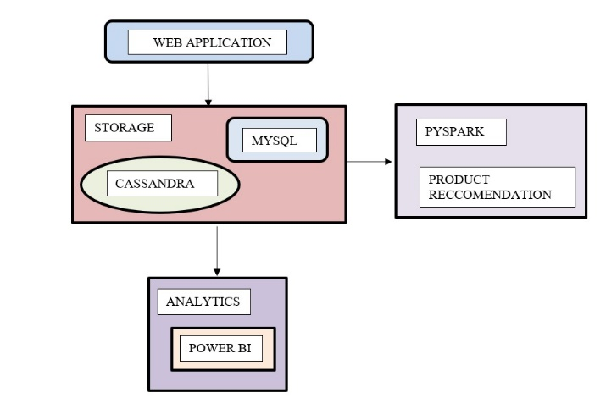

Figure 1: system Architecture

Data processing and analytics are performed using Python libraries Those tools help identify trends, calculate metrics, and generate actionable insights, such as average session duration or popular products. Processed data is then visualized using Power BI, which connects to Cassandra or processed data files to create interactive dashboards. These dashboards display key metrics like user engagement, product popularity, and session duration, enabling businesses to make data-driven decisions. Security measures, including encryption and access controls, are implement. The system is designed for scalability, using load balancing, efficient indexing, and query optimization to handle high traffic loads without performance bottlenecks. This end-to-end implementation ensures a robust, scalable, and secure solution for real-time user behavior tracking and analytics.

IV. RESULT

The login module serves as the primary authentication gateway for users accessing the system. It is designed with secure credential handling using encrypted input fields and a backend verification mechanism. Upon successful login, users are redirected to the personalized home interface. Invalid credentials trigger immediate alerts with retry options, ensuring both usability and security compliance.



Figure 2: Login page

The signup page allows new users to register securely by submitting required information such as username, email, and password. The system incorporates validation checks for password strength, duplicate accounts, and email format. Data submitted during registration is securely stored in the backend database after undergoing encryption and hashing protocols to ensure privacy and security.



Figure 3: Signup Page

The figure displays a personalized recommendation interface showcasing top products across diverse categories, including electronics (Xbox console, ASUS TUF Gaming monitor, iPhone), health (electric toothbrush), and fashion (athletic shoes). The system likely leverages user behavior analytics and machine learning algorithms to dynamically generate suggestions based on interaction history, preferences, or collaborative filtering.

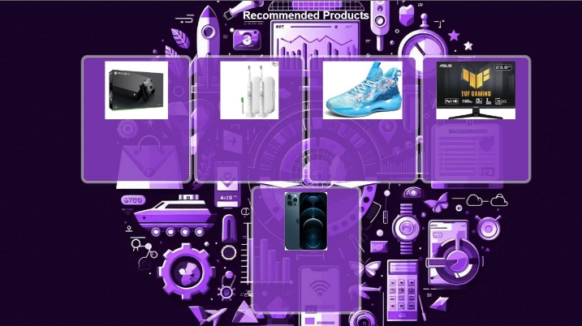

Figure 4.1: Home Page(Recommendation)

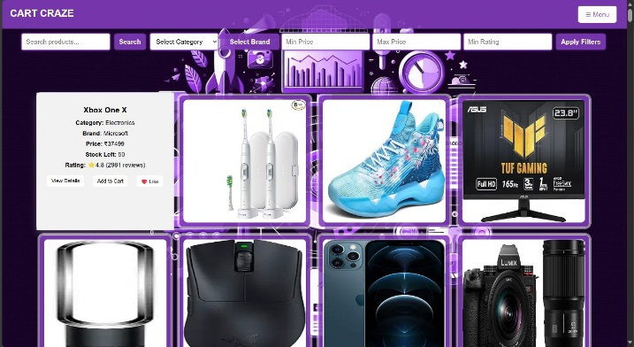

Figure 4.2 Home Page(List of Products)

The Report Issue page enables users to submit feedback or problems encountered within the system. Users can describe issues, select a category (e.g., login error, UI glitch), and optionally attach a screenshot. Submitted reports are stored securely and forwarded to the admin dashboard for review..

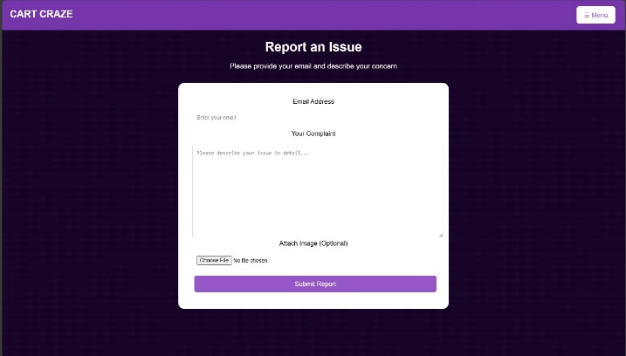

Figure 5: Report issue page

This module enables users to select and store products for future purchase. Items added to the cart are tracked in real-time, with updates synchronized to the backend system using Kafka producers to ensure a consistent shopping experience. The cart page includes quantity adjustment, removal, and subtotal calculation features, enhancing interactivity and decision-making efficiency.

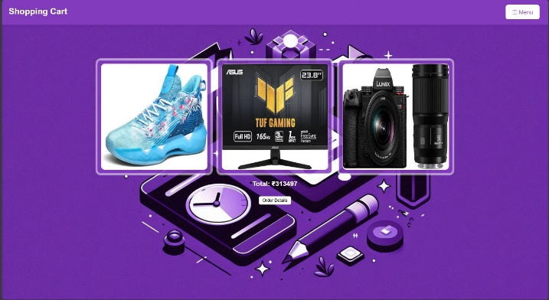

Figure 6: Add to cart page

The visualization highlights the top-performing brands and product categories based on user interactions. **Nike**, **Microsoft**, and **Philips** lead in brand engagement, while **Electronics**, **Fashion**, and **Health & Fitness** dominate category-wise interactions

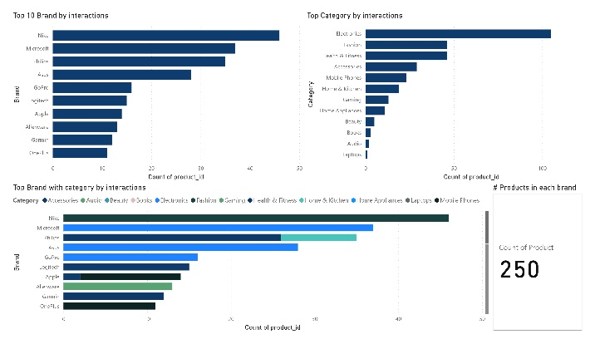

Figure 7 : (bar chart) Horizontal

The top 10 products by interactions are listed, showing **Product ID 1003** as the most engaged. This figure supports price-performance analysis and brand positioning strategies.

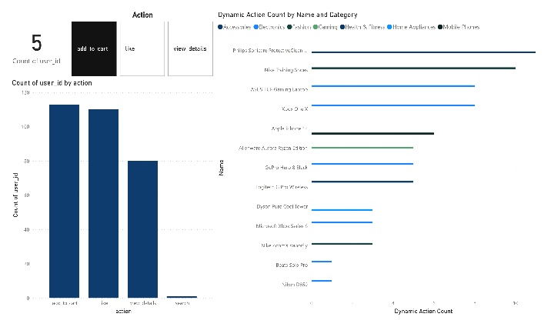

Figure 8 :Result (bar chart) Vertical

The figure illustrates the distribution of product ratings, with most products receiving scores between 4.2 and 4.9, indicating high customer satisfaction. A supporting table lists individual product ratings and stock levels. This visualization enables businesses to identify top-performing products and low-rated items, aiding in quality control and inventory optimizatio

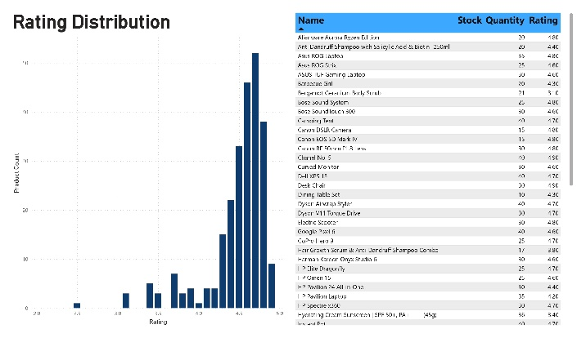

Figure 9: Data Analytics (Distribution)

V. CONCLUSION

This paper presented a scalable and efficient real-time user behavior tracking system designed to address the challenges of processing and analyzing high-frequency interaction data. By leveraging Apache Kafka for real-time data streaming, Cassandra for scalable storage, and Power BI for interactive visualization.

the system enables businesses to gain actionable insights and optimize strategies.

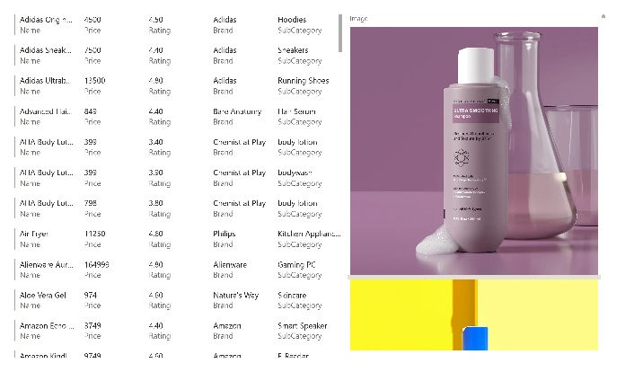

Figure 10: Final output

The figure represents the final output of the recommendation dashboard interface, integrating structured product data with dynamic visual previews to enhance user interaction and decision-making. On the left, a detailed table presents key product attributes such as **name, price, rating, brand**, and **subcategory**, covering a wide spectrum of items from **personal care and electronics to fashion and home appliances**.

VI. Limitations And Future work

While the proposed system effectively tracks and analyzes user behavior in real time, it currently relies on rule-based analytics and lacks deep integration with advanced machine learning models for adaptive personalization. Additionally, the system is optimized for web-based interactions and may not fully capture multi-channel or mobile behavior. Future work will focus on incorporating deep learning techniques for predictive user modeling, expanding data source integration to include mobile and IoT platforms, and enhancing the recommendation engine. Cloud-based deployment and automated anomaly detection will also be explored to improve scalability, resilience, and proactive user engagement.

REFERENCE

1. Gupta, A., et al. (2021). "Apache Kafka for Real-Time Data Streaming." *IEEE Transactions on Cloud Computing*.
2. Kreps, J., Narkhede, N., & Rao, J. (2011). "Kafka: A Distributed Messaging System for Log Processing." *Proceedings of the NetDB Workshop*.
3. Lakshman, A., & Malik, P. (2010). "Cassandra: A Decentralized Structured Storage System." *ACM SIGOPS Operating Systems Review*.
4. Patel, S., & Kumar, R. (2020). "Cassandra: A Distributed Storage Solution for Big Data." *Journal of Database Management*.
5. Patel, S., & Kumar, R. (2020). "Cassandra: A Distributed Storage Solution for Big Data." *Journal of Database Management*.
6. Marz, N., & Warren, J. (2015). *Big Data: Principles and Best Practices of Scalable Real-Time Data Systems*. Manning Publications.
7. Smith, J., et al. (2020). "Challenges in Real-Time Data Processing with Relational Databases." *Journal of Data Systems*.
8. Zhang, L., et al. (2022). "Hybrid Storage Systems for Real-Time Data Processing." *International Journal of Data Science*

.

1. Wang, Y., et al. (2021). "Performance Optimization in High-Traffic Real-Time Systems." *Journal of Systems Architecture*.
2. Brown, T., et al. (2021). "Power BI for Real-Time Data Visualization." *Business Analytics Review*.
3. Thomas, J., & Cook, K. (2005). *Illuminating the Path: The Research and Development Agenda for Visual Analytics*. IEEE Computer Society.
4. Anderson, M., et al. (2020). "Data Security and Compliance in Real-Time Systems." *IEEE Security & Privacy*.
5. Brewer, E. (2012). "CAP Twelve Years Later: How the 'Rules' Have Changed." *Computer*.
6. Johnson, R., & Lee, K. (2019). "NoSQL Databases for Scalable Real-Time Applications." *International Conference on Big Data*.
7. Dean, J., & Ghemawat, S. (2008). "MapReduce: Simplified Data Processing on Large Clusters." *Communications of the ACM*.
8. Shvachko, K., et al. (2010). "The Hadoop Distributed File System." *IEEE Symposium on Mass Storage Systems and Technologies*.
9. Chen, M., et al. (2016). "Big Data Analytics for Real-Time User Behavior Prediction." *IEEE Transactions on Big Data*.
10. Zhang, Y., et al. (2019). "Machine Learning for Real-Time User Behavior Analysis in E-Commerce." *IEEE Access*.
11. Zikopoulos, P., et al. (2013). *Understanding Big Data: Analytics for Enterprise-Class Hadoop and Streaming Data*. McGraw-Hill.
12. Gandomi, A., & Haider, M. (2015). "Beyond the Hype: Big Data Concepts, Methods, and Analytics." *International Journal of Information Management*.
13. Chandrasekaran, S., et al. (2003). "TelegraphCQ: Continuous Dataflow Processing for an Uncertain World." *CIDR Conference*.
14. Abadi, D. J., et al. (2005). "The Design of the Borealis Stream Processing Engine." *CIDR Conference*.
15. Toshniwal, A., et al. (2014). "Storm@Twitter." *ACM SIGMOD International Conference on Management of Data*.
16. Carbone, P., et al. (2015). "Apache Flink: Stream and Batch Processing in a Single Engine." *IEEE Data Engineering Bulletin*.
17. Liu, X., et al. (2018). "Real-Time User Behavior Modeling for Personalized Recommendations." *IEEE Transactions on Knowledge and Data Engineering*.
18. Zhang, H., et al. (2020). "Deep Learning for User Behavior Analysis in Real-Time Systems." *IEEE Transactions on Neural Networks and Learning Systems*.